Lab 2: Containerization & Kubernetes Orchestration
Task 1: Containerize a sample application using Docker

1. Objective
Containerize a sample Python (Flask) web application using Docker: write a Dockerfile, build an image from it, run a container from that image, and document both the resulting image layers and the container's runtime behaviour.

2. Sample Application
A small Flask application (app.py) was written for this lab. It exposes two HTTP endpoints:
- GET / — returns a JSON payload with a welcome message, the container's hostname, the current UTC time, and a visit counter that is read from and written to a file at /data/counter.txt (used later in Task 3 to demonstrate storage behaviour).
- GET /health — returns a simple JSON health-check payload {"status": "ok"}.
import os, socket
from datetime import datetime, timezone
from flask import Flask, jsonify

app = Flask(__name__)
DATA_DIR = os.environ.get("DATA_DIR", "/data")
COUNTER_FILE = os.path.join(DATA_DIR, "counter.txt")

def read_counter():
try:
with open(COUNTER_FILE, "r") as f:
return int(f.read().strip() or 0)
except FileNotFoundError:
return 0

def write_counter(value):
os.makedirs(DATA_DIR, exist_ok=True)
with open(COUNTER_FILE, "w") as f:
f.write(str(value))

@app.route("/")
def index():
count = read_counter() + 1
write_counter(count)
return jsonify({
"message": "Hello from the Lab 2 containerized Python app!",
"hostname": socket.gethostname(),
"visits_recorded_in_this_container": count,
"data_dir": DATA_DIR,
"time_utc": datetime.now(timezone.utc).isoformat(),
})

@app.route("/health")
def health():
return jsonify({"status": "ok"})

if __name__ == "__main__":
app.run(host="0.0.0.0", port=5000)

3. Dockerfile
Each instruction below produces its own image layer (except EXPOSE, which only adds metadata). requirements.txt is copied and installed before the application source is copied, so the dependency-install layer stays cached whenever only app.py changes.
# Layer 1: base image
FROM python:3.12-slim

# Layer 2: metadata / working directory
WORKDIR /app

# Layer 3: dependency manifest copied first so pip install is cached
# independently of application code changes
COPY requirements.txt .

# Layer 4: install dependencies
RUN pip install --no-cache-dir -r requirements.txt

# Layer 5: copy application source
COPY app.py .

# Layer 6: create data directory used for storage demo
RUN mkdir -p /data

# Metadata: document the port the app listens on
EXPOSE 5000

# Layer 7: default command to run the container
CMD ["python", "app.py"]

4. Building the Image
docker build -t lab2-python-app:1.0 . was run inside the app/ directory. BuildKit executes each instruction as a separate, cached step. Run the commands below yourself, then capture Screenshot 1.
cd lab2-docker\app
docker build -t lab2-python-app:1.0 .
docker images lab2-python-app
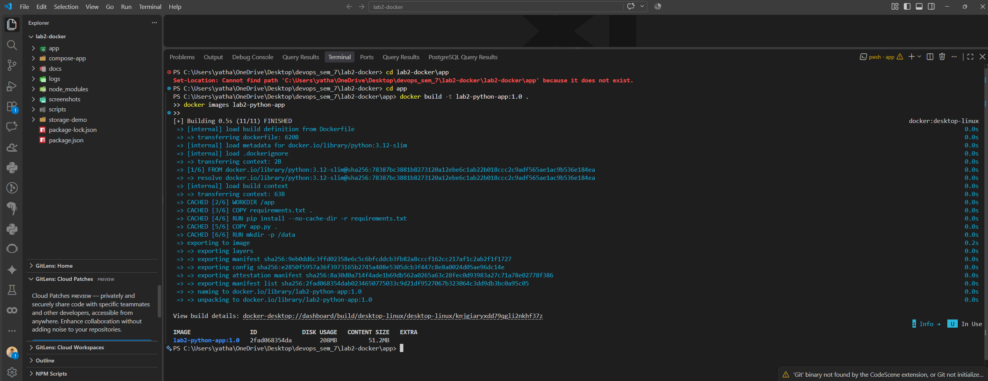

5. Running the Container & Verifying Behaviour
The image was run as a detached container, publishing container port 5000 to host port 5000, then exercised with curl. (In PowerShell, use curl.exe so you get the real curl output instead of the Invoke-WebRequest alias; in Git Bash / WSL, plain curl already works.)
docker run -d -p 5000:5000 --name lab2-app lab2-python-app:1.0

curl.exe -s http://localhost:5000/
curl.exe -s http://localhost:5000/health

docker history lab2-python-app:1.0
docker logs lab2-app
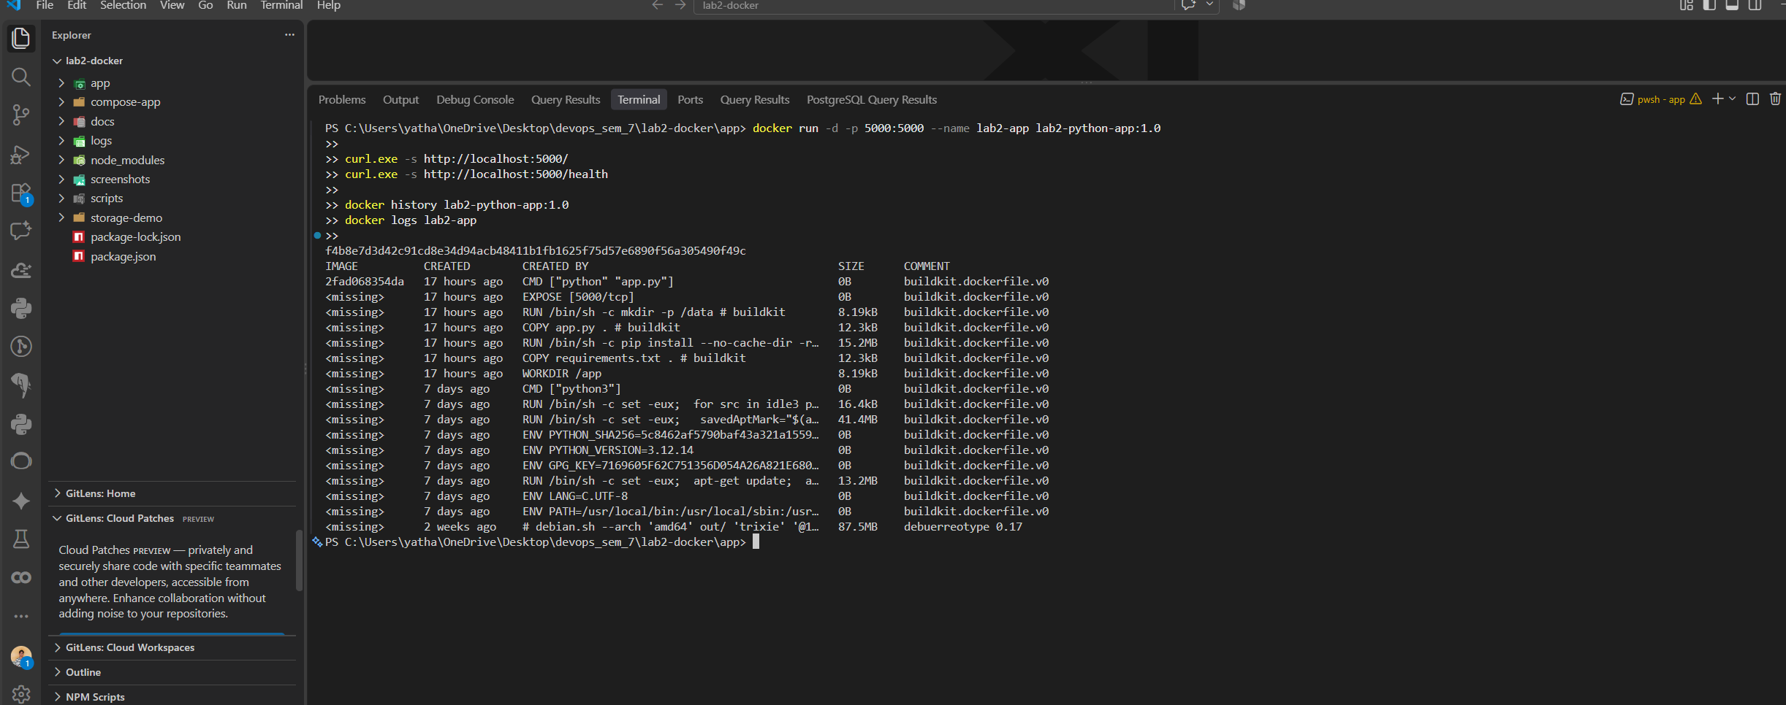

6. Image Layer Documentation
docker history lab2-python-app:1.0 lists every layer in the final image, most recent first. The seven layers contributed directly by this Dockerfile are:
# | Dockerfile Instruction | Layer Effect | Size Added
1 | FROM python:3.12-slim | Pulls the Debian-based Python 3.12 base image (multiple inherited layers) | ~190 MB (base)
2 | WORKDIR /app | Metadata layer — sets working directory, no files added | 8.19 kB
3 | COPY requirements.txt . | New layer containing requirements.txt | 12.3 kB
4 | RUN pip install ... | New layer with Flask 3.0.3 and its dependencies installed | 15.2 MB
5 | COPY app.py . | New layer containing the application source | 12.3 kB
6 | RUN mkdir -p /data | New layer creating the empty /data directory | 8.19 kB
7 | EXPOSE 5000 / CMD | Metadata only (documented port + start command) — no filesystem change | 0 B

Final image size: 208 MB on disk / 51.2 MB compressed content (docker images lab2-python-app). Because Docker layers are cached and content-addressed, rebuilding after only editing app.py re-uses layers 1–3 unchanged and only re-creates layers 5–7 — layer 4 (the slow pip install) is also skipped since requirements.txt did not change.

7. Container Behaviour Documentation
Property | Observed Value
Container status | running (docker inspect .State.Status)
Container IP (default bridge) | 172.17.0.2
Published port mapping | 0.0.0.0:5000 -> 5000/tcp
Process inside container | python app.py (Flask dev server, PID 1)
Memory usage (docker stats) | ~22 MiB / 7.6 GiB limit (0.29%)
CPU usage (docker stats) | 0.01% (idle, single Flask worker)
Restart count | 0

docker logs lab2-app confirms the Flask development server started, bound to 0.0.0.0:5000, and logged one 200 OK access line per request received — matching the two curl calls made against it.

8. Conclusion
The Flask application was successfully containerized: the Dockerfile defines seven distinct, cacheable layers, docker build produced a 208 MB image, and the resulting container served real HTTP traffic on port 5000 while docker history, docker inspect, docker logs and docker stats were used to document both the image's layered structure and the running container's behaviour.

